Introductions to Cinder over Aqua

Version: 0.1
Author: Hui Shao

Document Status: |  | WorkInProgress (W) |  |  | Draft (D) | Issued (I) | Released (R)
Revision History:
Date | Version |  | By | Description
10/16/2014 | 0.1 |  | Hui Shao | Initial Draft

Contents
1. Overview 4
1.1 Scope 4
1.2 Background and Goals 4
2. Overall Architecture 5
2.1 Reference Architecture Description 5
2.2 Work flow 6
3. Cinder Volume Driver for FUSE 7
4. Enhancements on Cinder Commands and API 8
4.1 Usage of New Cinder Client Commands 9
4.1.1 export volume 9
4.1.2 delete export 10

Overview
The objective of this document is to introduce how the Aqua storage is exported as OpenStack Cinder volume in order to provide block storages. It describes how a virtual disk data-object on Aqua gets exported as a Cinder volume, and how the volume can be accessed. Also, the document briefly describes the programming efforts made for such a purpose.

Scope
This document is primarily focus on the overall infrastructure architecture by assuming you have knowledge on:
- Aqua basic concepts - what is Aqua and what it is for
- CdmiFUSE - mount the Aqua storage as a normal file system on Linux
- iSCSI - block-level disk access over internet, what are iSCSI target and initiator
- OpenStack - a popular open-source software cloud computing software platform that provides IaaS
- Cinder - the storage management of OpenStack
This document will not describe the above any more, please refer to other documents or internet if you are introduced with more details.

Background and Goals
Aqua from XOR media provides a cloud storage over various disk infrastructure, its Frontend takes CDMI as interface specification to allow users to create, retrieve, update and delete data elements from the Cloud.
CdmiFUSE runs on application server represents the cloud storage of Aqua as a regular file system by interacting with Aqua via CDMI specification. This present a transparent usage and easy the users. CdmiFUSE also includes built-in caches to improve IO performance while reducing the network traffic with Aqua.
In many scenarios of integration, the users' application may be built based on block devices directly instead of a file system, where iSCSI is known as the most popular data exchange standard. This Cinder-over-Aqua is to meet such a purpose to provide block device based access in addition to file system based access.
The goals of such a solutions will be:
- The approach should provide block device based access via standard iSCSI
- The block devices should be mounted and accessed in OpenStack virtual machines
- The applications other than OpenStack virtual machines should also be able to access the block devices
- The volume or iSCSI target should be created/deleted with remote commands or API
- The approach should be benefited with the IO performance enhancements by CdmiFUSE
- The approach should take minimal installation of OpenStack by excluding the OpenStack function other than storage

Overall Architecture

Reference Architecture Description
The following figure describes the proposed reference architecture of Cinder-Over-Aqua. 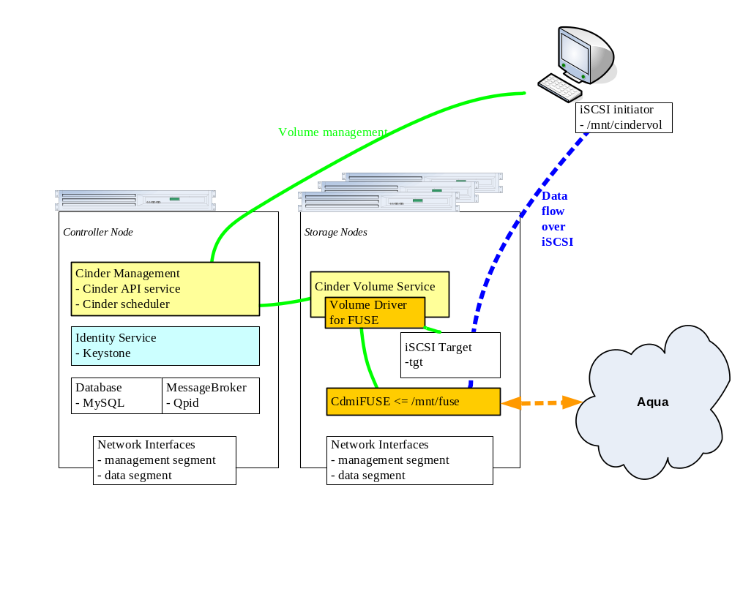
It is a reduction of normal OpenStack deployment, and involves two type of OpenStack nodes:
- Controller Node, and
- Storage Node(s)

The Controller Node runs the management part of Cinder, includes CinderAPI service and Cinder Scheduler service. Also it runs the common dependencies of OpenStack that required by Cinder services. They are OpenStack keystone (the identify service), MySQL database and Qpid message broker.

The StorageNode(s) is the machine that exports Aqua data objects as iSCSI targets, which involves CdmiFUSE service and tgt service. Each of them runs Cinder Volume service that loads the new developed volume driver for FUSE.

Work flow

The following figure briefly describes the procedures of create volume, export volume and remove export. delete volume is omitted here.

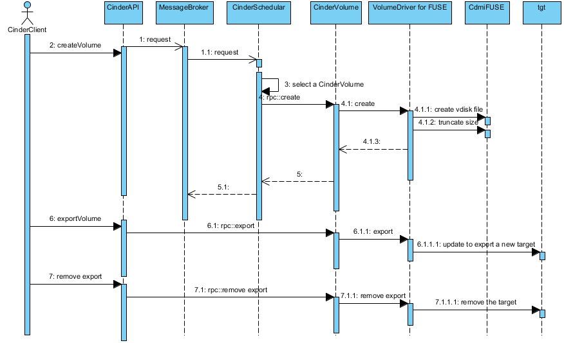

Cinder Volume Driver for FUSE

The Cinder volume driver for FUSE is a new driver for this approach in addition to official OpenStack release. It implements each volume driver entry points, including create, export, delete and so on, by operating on the mounted FUSE file system and communicating with tgt daemon
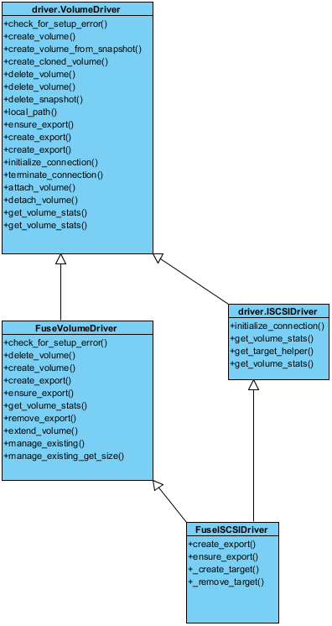

Enhancements on Cinder Commands and API
Basically, all the Cinder volumes in the official OpenStack deployment are design for the use of OpenStack virtual machine, they appear private within OpenStack and the application other than OpenStack would not be able to access those volumes

Besides the above Cinder volume driver for CdmiFUSE, another part of the approach is to exceed such a limitation of OpenStack, and allow those Cinder volumes exported from Aqua to be accessible by the applications other than OpenStack virtual machines. Such effort basically is to create a new set of Cinder client command, remote API, Volume RPC and routine to volume driver and etc, in order to make Cinder support "export" iSCSI volumes with no restriction of OpenStack virtual machines. The involves modifications are:
- In shell.py, introduced new Cinder client commands "export" and "delete-export"
- Modify and make sure the volumes.py, manager.py and client.py can compose new APIs to send to Cinder API service
- Modify volume_actions.py and api.py and make sure Cinder API service and receive and recognize the new requests.
- Modify rpcapi.py, volumes.py and make sure the Cinder Volume on Storage node can receive and handling correctly the new APIs

Usage of New Cinder Client Commands
After the system has been correctly set up by following Mini-Cinder Manual.doc, you are able to execute the new commands

export volume
# cinder export <volume-display-name>

This command is to export a Cinder volume, previously created by "cinder create", as a iSCSI target thru tgt.
For example, assume a volume v33 has been created with ID b936a138-7d76-4f8a-82ac-048f66bd74e8 assigned by OpenStack, you will see the output like the following by executing the export command:
# cinder export v33
('v1/volume/_action: [%s]', {'os-export': None})
('v1/volume/url=[%s]', u'/volumes/b936a138-7d76-4f8a-82ac-048f66bd74e8/action')

And tgt-admin can confirm such a iSCSI target has been set up:
# tgt-admin --show
...
Target 4:
iqn.2010-10.org.openstack:volume-b936a138-7d76-4f8a-82ac-048f66bd74e8
System information:
Driver: iscsi
State: ready
I_T nexus information:
LUN information:
LUN: 0
Type: controller
SCSI ID: IET 00040000
SCSI SN: beaf40
Size: 0 MB, Block size: 1
Online: Yes
Removable media: No
Prevent removal: No
Readonly: No
Backing store type: null
Backing store path: None
Backing store flags:
LUN: 1
Type: disk
SCSI ID: IET 00040001
SCSI SN: beaf41
Size: 2147 MB, Block size: 512
Online: Yes
Removable media: No
Prevent removal: No
Readonly: No
Backing store type: rdwr
Backing store path: /mnt/fuse/volumes/volume-b936a138-7d76-4f8a-82ac-048f66bd74e8
Backing store flags:
Account information:
ACL information:
ALL

delete export
# cinder delete-export <volume-display-name>

This command is to remove the previously exported iSCSI target.
Continued with the above sample, you will see the similar output like the following by executing this command:
cinder delete-export v33
('v1/volume/_action: [%s]', {'os-delete-export': None})
('v1/volume/url=[%s]',u'/volumes/b936a138-7d76-4f8a-82ac-048f66bd74e8/action')

And tgt-admin can confirm such a iSCSI target is no more available

Key to Document status Codes: Work in Progress (W)An incomplete document, designed to guide discussion and generate beedback that may include several alternative requirements for considerationDraft (D)A document in specification format considered largely complete, but lacking review by other vendors. Drafts are susceptible to substantial change during the review processIssued (I)A stable document, which has undergone rigorous vendor review and is suitable for product desing and development, cross-vendor interoperability, and for certification tesing.Released (R)A stable document, reviewd, tested and validated, suitable to enable cross-vendor interoperability

